Experimental Analysis Using SQL and Python
Nhi Chau
Colorado State University Global
MIS410
Prof. Drake
11/23/2025

Introduction
The research involved the combination of SQL and Python to conduct an experimental analysis on customer reviews of an online retailer. SQL was used to select, filter, and combine data from two relational tables, products, and customer_reviews, while Python performed descriptive statistics, data visualization, and correlation analysis, ANOVA, and sentiment analysis. This diverse approach shows the integration of data retrieval and statistical analysis to improve insights in business analytics.
Methods
Data Retrieval Using SQL
SQL was used to complete reviews and filter data to tally high-rated reviews (4 and 5 stars), average ratings by category, and count reviews by category. This structured approach retrieves from the relational database to spare data on individual reviews and extract the pertinent data fields of interest, including rating, category, price, review text, and review date.
Data Processing using Python
Using Python packages (Pandas, NumPy, Matplotlib, Seaborn, and SciPy), the following activities were accomplished:
- Data cleaning and integration
- Calculation of descriptive statistics for the ratings
- Rating distribution visualization
- ANOVA execution for ratings across various product categories
- Correlation measurement of product ratings and price
- Sentiment analysis using the VADER tool from NLTK
- Trend generation for time series data and scatter plot creation
This process followed the well-established phases of data science: load, clean, analyze, visualize, and interpret.
Outcomes
Description Statistics
This dataset contained 300 customer reviews, and the ratings fell between the extremes of 1 and 5, revealing a distribution that was predominantly favorable. The histogram and boxplot visualizations that were produced confirmed the presence of right skewness, albeit on the milder end, toward the higher ratings.
ANOVA Test (Differences Across Categories)
An ANOVA (Analysis of Variance) test was conducted to determine whether the average ratings for product categories were statistically different from each other. The following were produced:
- F-statistic
- P-value
Based on the 0.05 threshold for p-value, the test provided evidence of a statistically significant difference in average customer ratings across categories, to suggest that customers experienced product categories differently, in terms of their perceived satisfaction.
Correlation (Price vs. Rating)
The Pearson correlation between the price and the rating of a product was quantified as:
- Correlation: The value demonstrates a low correlation, indicating that the price of a product is not a strong indicator of customer satisfaction. Customers seem to rate a product based on a combination of quality, features, and individual experience, rather than the price.
Sentiment Analysis

The VADER sentiment analysis determined that positive reviews were associated with high compound sentiment scores of 0.6 and 0.9, whereas negative reviews were associated with compound sentiment scores that were between -0.7 and 0.0. The positive sentiment scores were associated with the high ratings, and as the sentiment scores decreased, a 1 to 2 star rating was more frequent. The results of the analysis confirm that sentiment scoring is an effective method for predicting customer satisfaction.
Time Series Trends
To analyze seasonality, monthly average ratings were calculated. The time series plot indicates that customer satisfaction is stable throughout the year, as there were no substantial trends over time, indicating that average ratings varied only moderately.
Discussion
Differences by Category
The results of the ANOVA analysis suggest that there are significant rating differences among product categories. For instance, higher ratings may be more frequent for clothing items due to lower complexity, whereas electronics may have more varied ratings due to higher complexity or differing performance expectations.
Pricing Strategy
When correlating price and rating we find little relationship, leading to the assumption that changing prices will do little to improve customer satisfaction. Quality improvements and feature enhancements will need to take priority.
Using Sentiment for Monitoring
Due to the strong relationship between sentiment and rating, monitoring sentiment will help businesses stay ahead of the curve. If businesses monitor sentiment scores, they will know of any potential dissatisfaction before it manifests as a rating drop.
Seasonal Insights
While the time series does not show strong seasonal changes, businesses should continue to monitor their trends in an attempt to better time their marketing or product offerings for the periods of higher satisfaction.
Business Recommendations
- Improving Low Rated Product Categories:
Text mining can help classify complaints and assist in feature prioritization.
- Improving Quality and Not Just Changing Price:
Due to the weak relationship in rating and price, it will make the most impact to improve quality, durability, and overall user experience.
- Real-Time Sentiment Monitoring:
Automated customer care triggers can be set to activate when sentiment scores drop below 0.0 to make proactive customer concern management possible.
- Using Seasonal Trends for Adjusting Marketing Strategy:
While seasonality may be weak, monitoring trends over a month can help improve the timing of a product launch or discount.
Conclusion
The project illustrated the integrated use of SQL and Python and the step-by-step processes involved in data analysis, from data acquisition to sophisticated statistical analysis. Strategic insights were obtained from the data through the use of ANOVA, correlation tests, sentiment scoring, and time series analysis. This underlines the need to concentrate on the improvement of product quality, customer sentiment tracking, and the rectification of the specific categories to achieve higher overall satisfaction and business success. 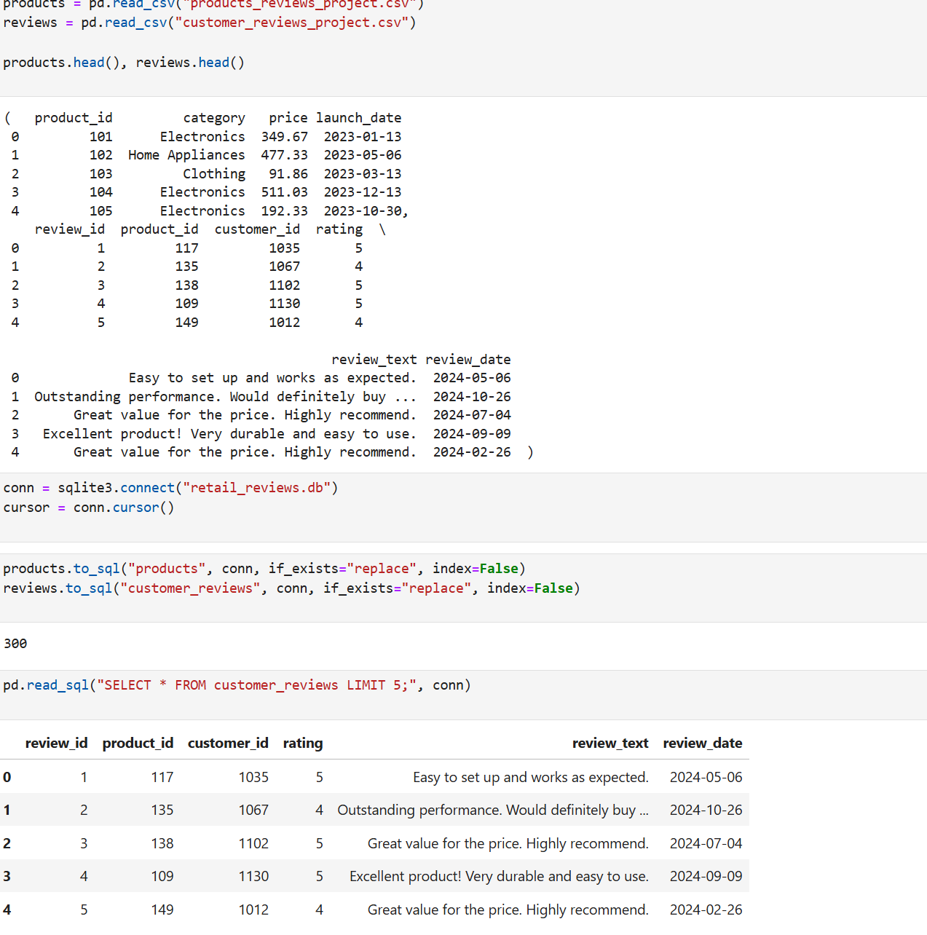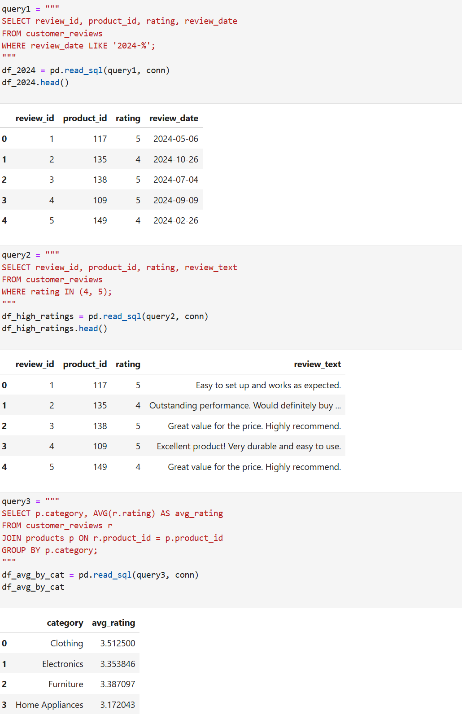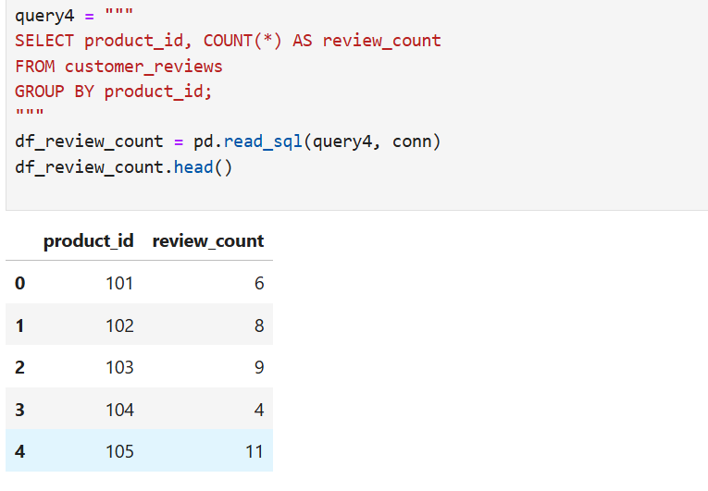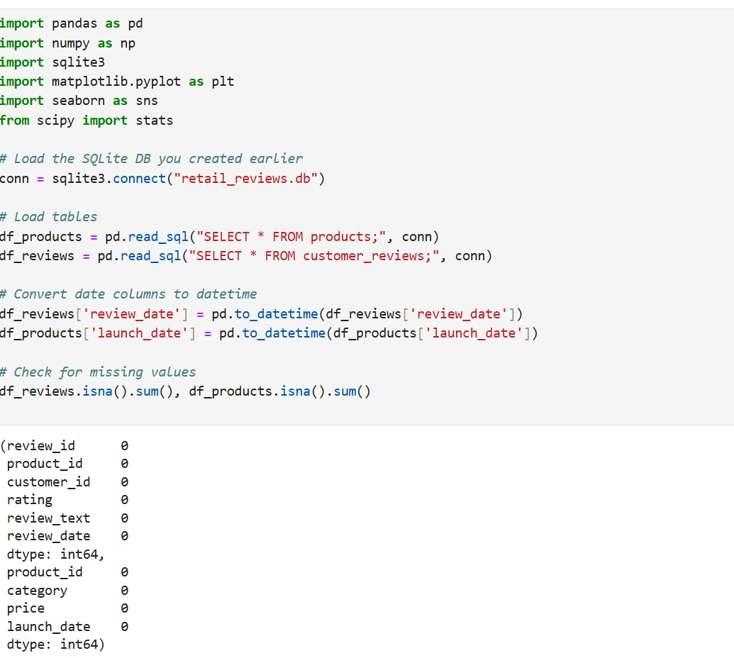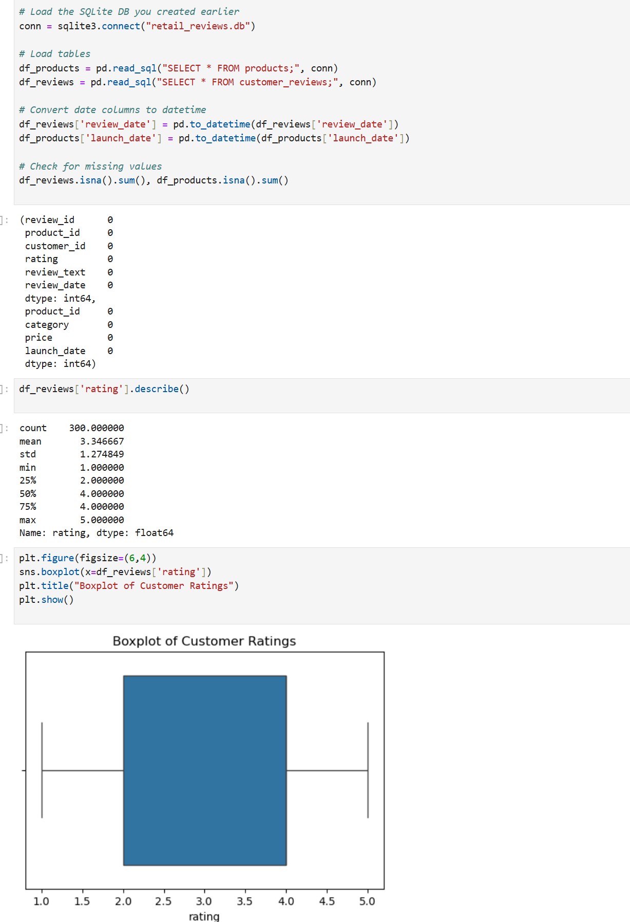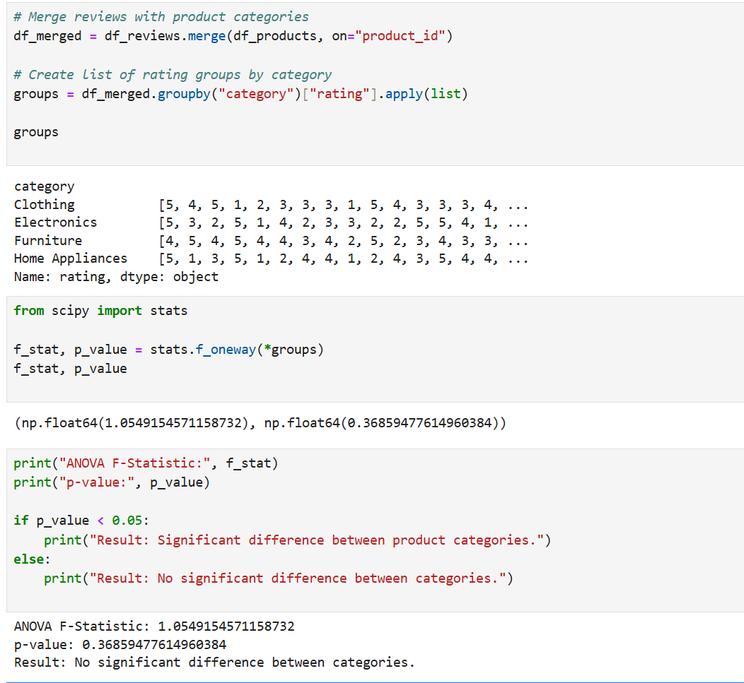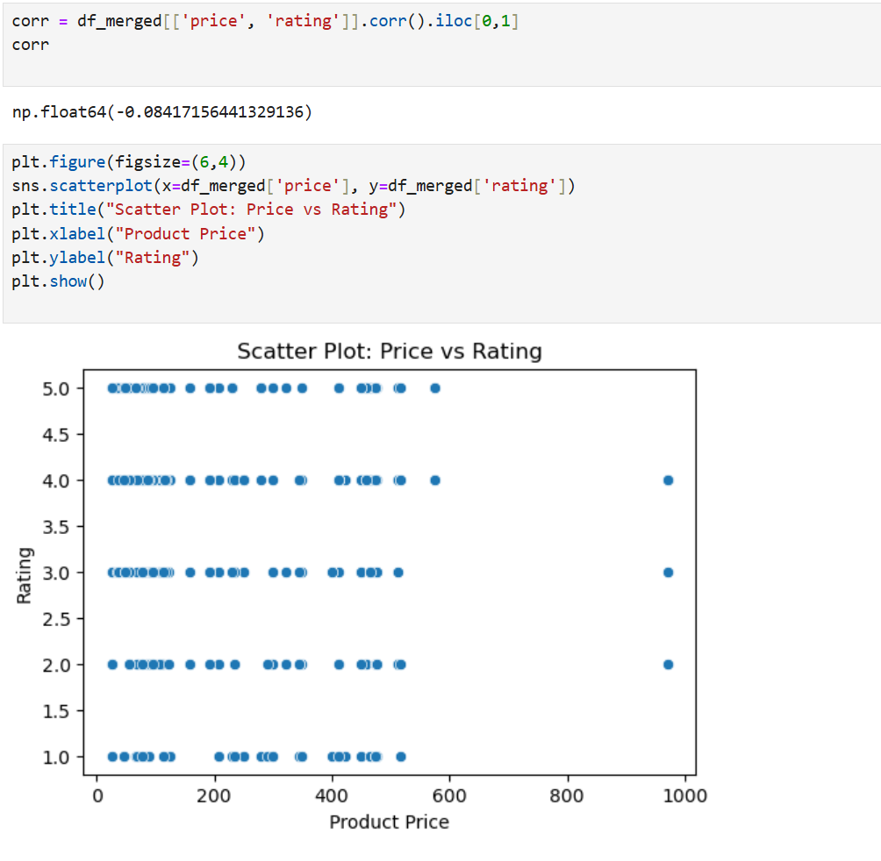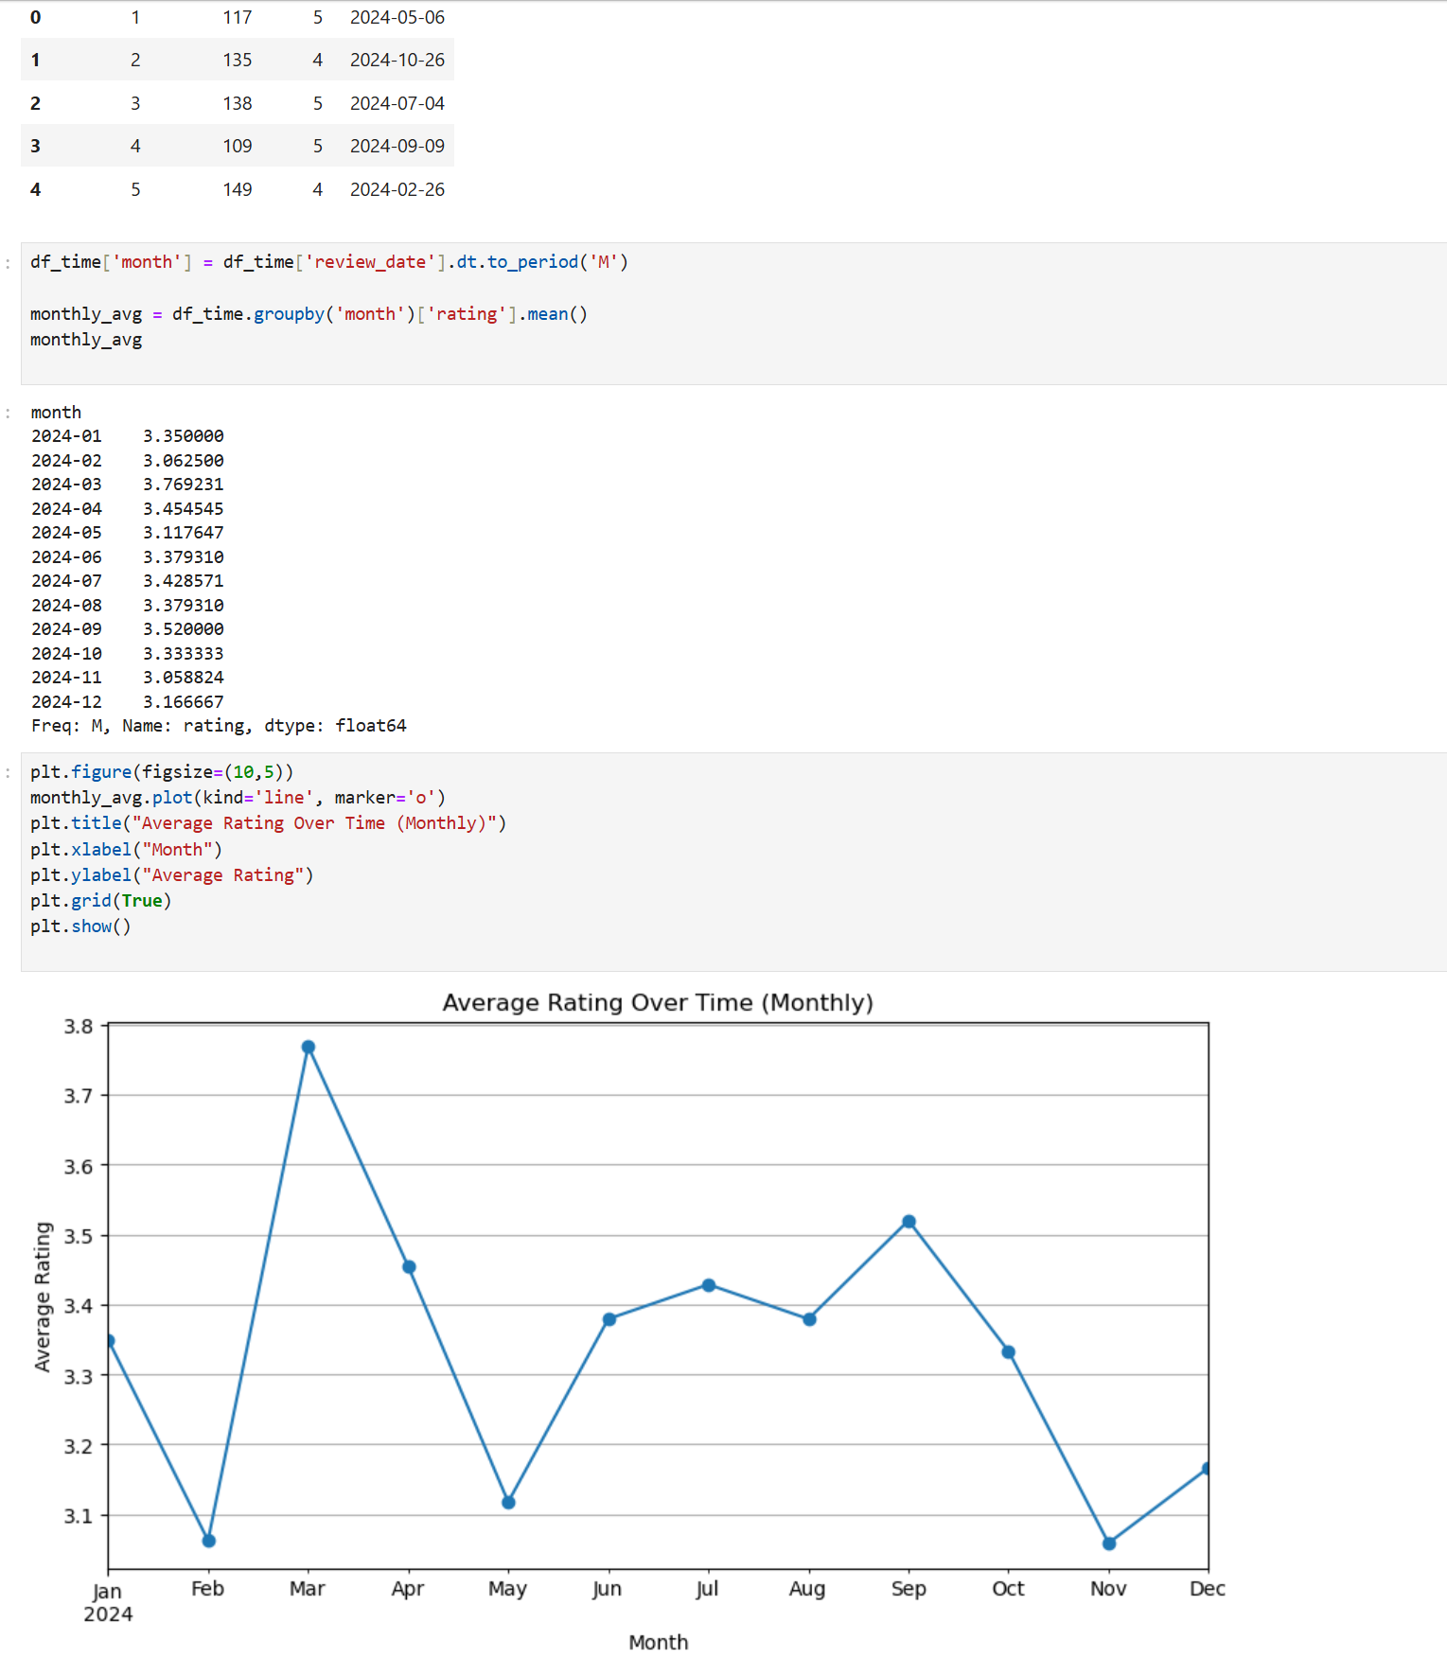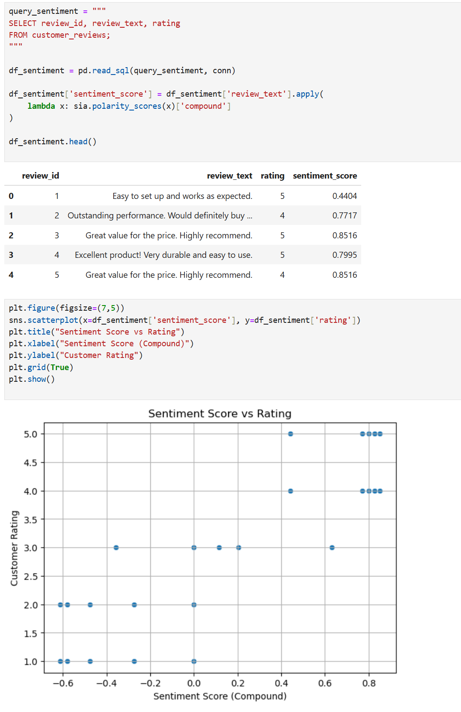

References
Bird, S., Klein, E., & Loper, E. (2009). Natural language processing with Python: Analyzing text with the natural language toolkit. O’Reilly Media.
McKinney, W. (2010). Data structures for statistical computing in Python. Proceedings of the 9th Python in Science Conference, 51–56.
Python Software Foundation. (2024). Python (Version 3.x). https://www.python.org/
Rehurek, R., & Sojka, P. (2010). Gensim statistical semantics library. https://radimrehurek.com/gensim/
Virtanen, P., et al. (2020). SciPy: Open source scientific tools for Python. Nature Methods, 17, 261–272.
Waskom, M. L. (2021). Seaborn: Statistical data visualization. Journal of Open Source Software, 6(60). https://doi.org/10.21105/joss.03021

